User-Defined Operations for Reduce and Scan
user-defined operations reduce, user-defined scan, user-defined
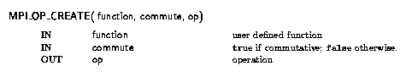
MPI_Op_create(MPI_User_function *function, int commute, MPI_Op *op)
MPI_OP_CREATE( FUNCTION, COMMUTE, OP, IERROR) EXTERNAL FUNCTION
LOGICAL COMMUTE
INTEGER OP, IERROR
MPI_OP_CREATE binds a user-defined global operation to an op handle that can subsequently be used in MPI_REDUCE, MPI_ALLREDUCE, MPI_REDUCE_SCATTER, and MPI_SCAN. The user-defined operation is assumed to be associative. If commute = true, then the operation should be both commutative and associative. If commute = false, then the order of operations is fixed and is defined to be in ascending, process rank order, beginning with process zero. The order of evaluation can be changed, taking advantage of the associativity of the operation. If commute = true then the order of evaluation can be changed, taking advantage of commutativity and associativity. associativity, and user-defined operation commutativity, and user-defined operation
function is the user-defined function, which must have the following four arguments: invec, inoutvec, len and datatype.
The ANSI-C prototype for the function is the following.
typedef void MPI_User_function( void *invec, void *inoutvec, int *len,
MPI_Datatype *datatype);
The Fortran declaration of the user-defined function appears below.
FUNCTION USER_FUNCTION( INVEC(*), INOUTVEC(*), LEN, TYPE)
<type> INVEC(LEN), INOUTVEC(LEN)
INTEGER LEN, TYPE
The datatype argument is a handle to the data type that was passed into the call to MPI_REDUCE. The user reduce function should be written such that the following holds: Let u[0], ... , u[len-1] be the len elements in the communication buffer described by the arguments invec, len and datatype when the function is invoked; let v[0], ... , v[len-1] be len elements in the communication buffer described by the arguments inoutvec, len and datatype when the function is invoked; let w[0], ... , w[len-1] be len elements in the communication buffer described by the arguments inoutvec, len and datatype when the function returns; then w[i] = u[i]ov[i], for i=0 , ... , len-1, where o is the reduce operation that the function computes.
Informally, we can think of invec and inoutvec as arrays of len elements that function is combining. The result of the reduction over-writes values in inoutvec, hence the name. Each invocation of the function results in the pointwise evaluation of the reduce operator on len elements: i.e, the function returns in inoutvec[i] the value invec[i]oinoutvec[i], for i = 0,.....,count-1, where o is the combining operation computed by the function.
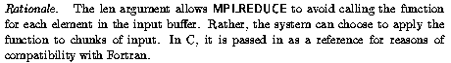
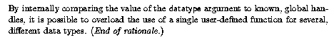
General datatypes may be passed to the user function. However, use of datatypes that are not contiguous is likely to lead to inefficiencies.
No MPI communication function may be called inside the user function. MPI_ABORT may be called inside the function in case of an error.
